Easter bunny made of pom-pom | 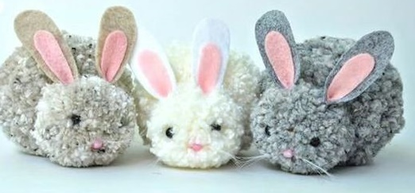

Materials:
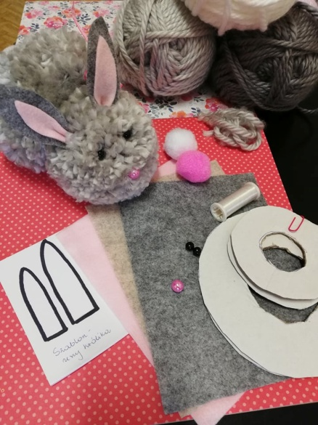 | - Prepare your work carefully. Choose a given colour of your crewel, felt for rabbit’s ears. Prepare 2 black beads for rabbit’s eyes and 1 pink for its nose. Prepare fly line for moustache and 1 pom-pom for the tail
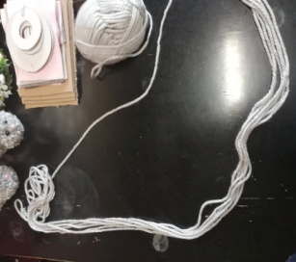 | - prepare a long piece of crewel and fold it 6 times (przygotuj długi kawałek włóczki złożonej na ok 5 warstw)
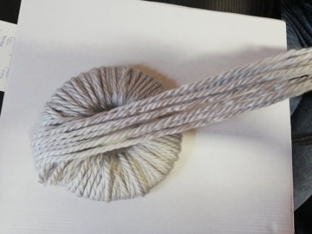 | - Wind the crewel on two joined cardboard circles. You can add extra layers of crewel. The ending of the crewel slide under  - Make sure that you wind the crewel tightly and evenly with a thick layer
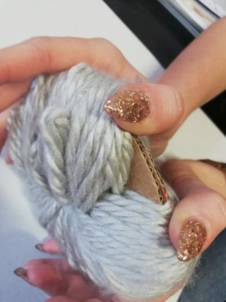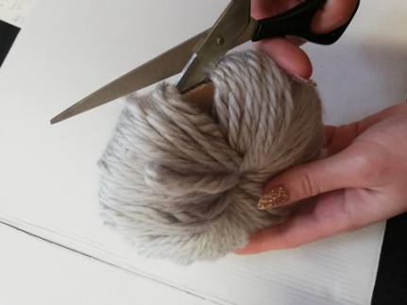 | - Separate the threads to see the cardboard circles. Put scissors between the circles and cut the threads along the circles, making sure the threads do not slip off the circles.
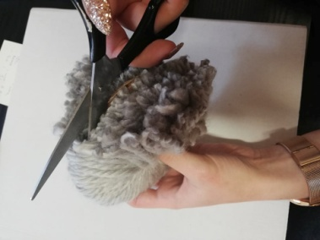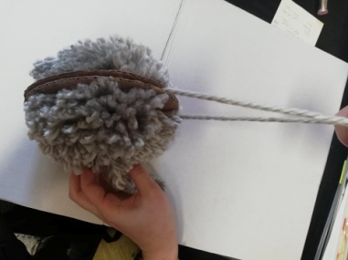 | - When half of the circle is cut, try to slip a thread (min 30 centimeters long) between cardboard circles. When you cut the whole crewel around the circle tie the thread with a strong double knot.
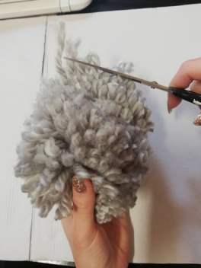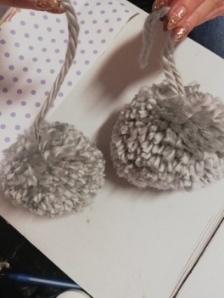 | - Take off the pom-pom from the circles. Cut the crewel to make sure that the pom-pom has a nice shape. Please don’t cut off the thread you tied to the pom-pom. The first pom-pom is ready.  - The second pom-pom do exactly the same way.
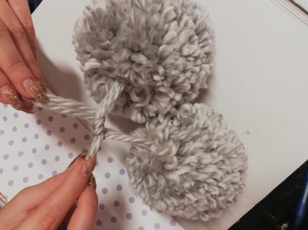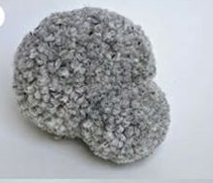 | - Join two pom-poms with a longer thread which you used to join them. The body of the rabbit is ready.
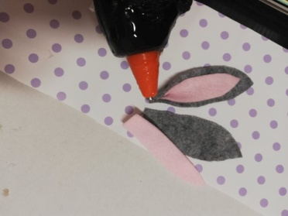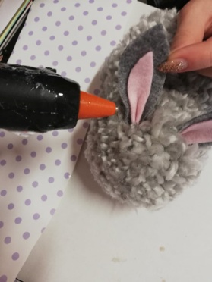 | - Cut out the rabbit’s ears from felt. You can use a ready pattern for that. Make the first layer grey or beige, whereas the inside should be pink. Stick felt with hot glue.  - Squeeze the bottom part of the ears and glue them.  - Stick them to the rabbit’s head.  - Rabbit’s eyes (black beads) should be glued or sewed.
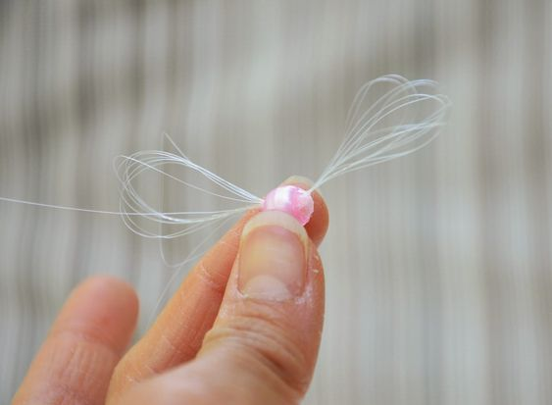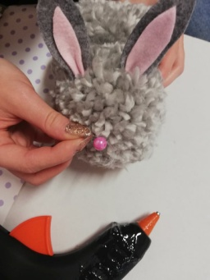 | - Make moustache from fly line 4-5 pieces of fine line tie on a pink bead forming a moustache. Cut them evenly.  - Do the same with the nose just like with the eyes
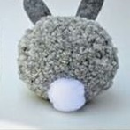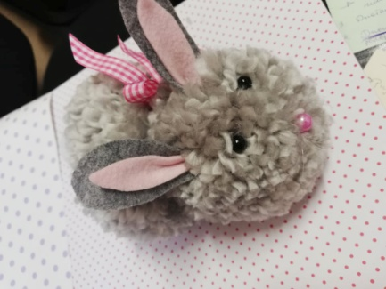 | - Attach the pom-pom to the rabbit’s bottom, it is going to be its tail.(hot glue)  - You can decorate the rabbit as you wish, for example by sticking to it a bow.  Easter bunny is ready. Bravo You!
